

**Team Id :** NM2025TMID19487

**Team Leader :** Abdul Basith M F

**Team Member 1 :** Ilayaraja T

**Team Member 2 :** Manofrancies A

**Team Member 3 :** sheerin nisha K





**SERVICE NOW** : **Laptop service request catalog Item**

**(service now project report )**

**Introduction:**

The Laptop Service Request Catalog Item project is designed to simplify how employees can request laptops through the ServiceNow Service Catalog. This project focuses on building a self-service portal item where users can submit requests by filling in essential details like laptop model, justification.

**Problem Statement**

The current process of requesting laptops in the organization is manual and time-consuming. Employees face delays due to lack of a self-service option, no proper tracking of requests, and inconsistent data collection. This leads to inefficiency in handling laptop requirements and increases dependency on administrators.

**Objective**

* **T**o automate the laptop request process using ServiceNow.
* To provide a self-service catalog item for employees to raise laptop requests.
* To ensure each request is tracked with a unique request number.
* To apply UI policies and UI actions for better user experience and validation.
* To migrate changes using update sets and test them in different instances.



**Skills**

* ServiceNow System Administration
* Catalog Item Creation & Variables
* UI Policy & UI Action
* Update Set Management
* Testing in Service Portal

**Project Flow:**

The development of the Laptop Service Request Catalog Item was carried out in a series of well-defined milestones, ensuring that each step of the process was properly implemented, tested, and validated.

**Milestone 1**: Update Set Creation

* The project began with the creation of a Local Update Set in ServiceNow.
* This step was very important as it ensured that every configuration, customization, and development made in the instance would be tracked.
* The Update Set was marked as current, so all subsequent changes were automatically captured.



Create Local Update set

* Open service now.
* Click on All >> search for update sets
* Select local update sets under system update sets
* Click on new
* Fill the following details to create a update set as: “Laptop Request”
* Click on submit and make current
* By clicking on the button it activates the update set

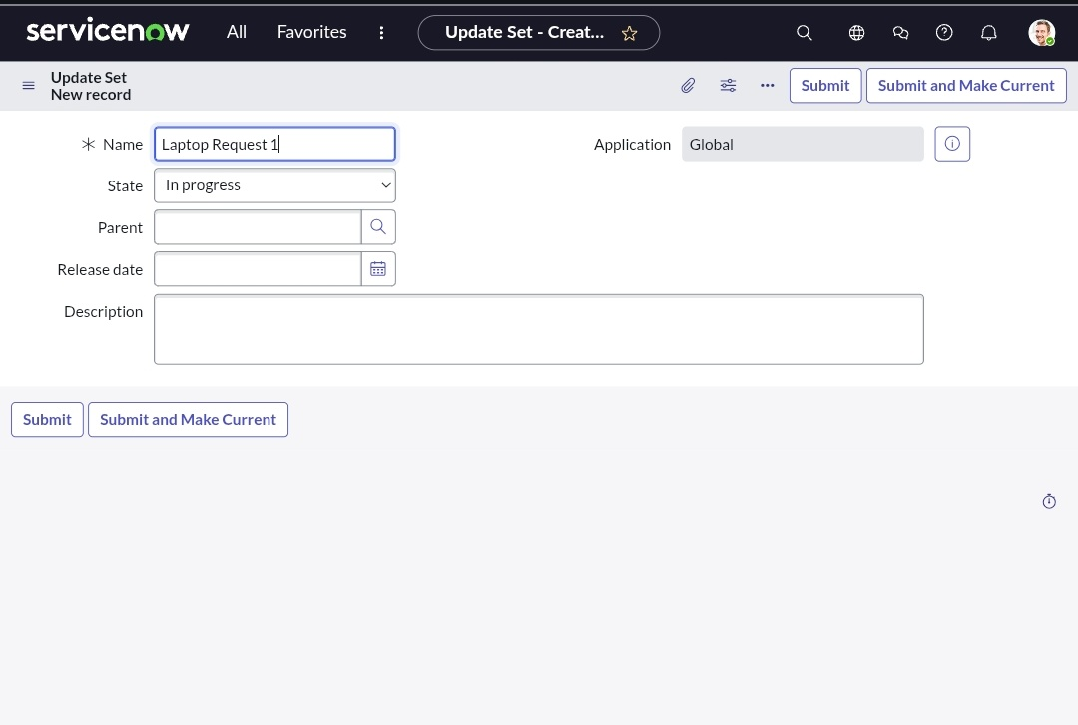

**Milestone 2**: Service Catalog Item Development



* A new Service Catalog Item named Laptop Request was created under the Hardware category.

**Several variables were added to collect input from users, such as:**

* Laptop Model – to specify the required laptop brand/model.
* Justification – to provide the reason for requesting a laptop.
* Additional Accessories – to allow employees to request extra items like a keyboard, mouse, or bag.

This formed the frontend request form that employees would use in the Service Portal.

Create Service Catalog Item

* Open service now.
* Click on All >> service catalog
* Select maintain items under catalog definitions
* Click on New.



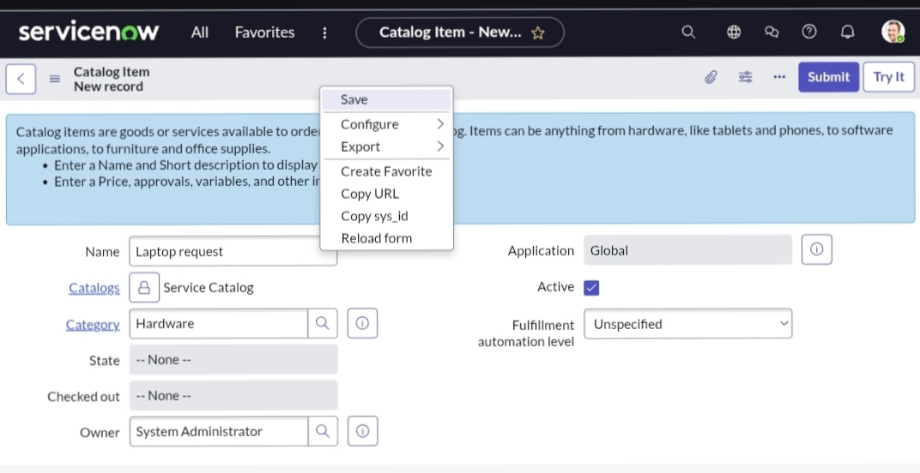

Add variables

Step1:

After saving the catalog item form scroll down and click on variable(related list)

Click on new and enter the details as below

1. Variable 1:Laptop Model

Type: Single line text

Name: laptop_model

Order:100

Click on submit

Again click on new and add Remaining variables in the above process

Variable 2:Justification

Type: Multi line text

Name: justification

Order:200

3. Variable 3:Additional Accessories

Type: Checkbox

Name: additional_accessories

Order:300

4. Variable 4: Accessories Details

Type: Multi line text

Name:accessories_details

Order:400

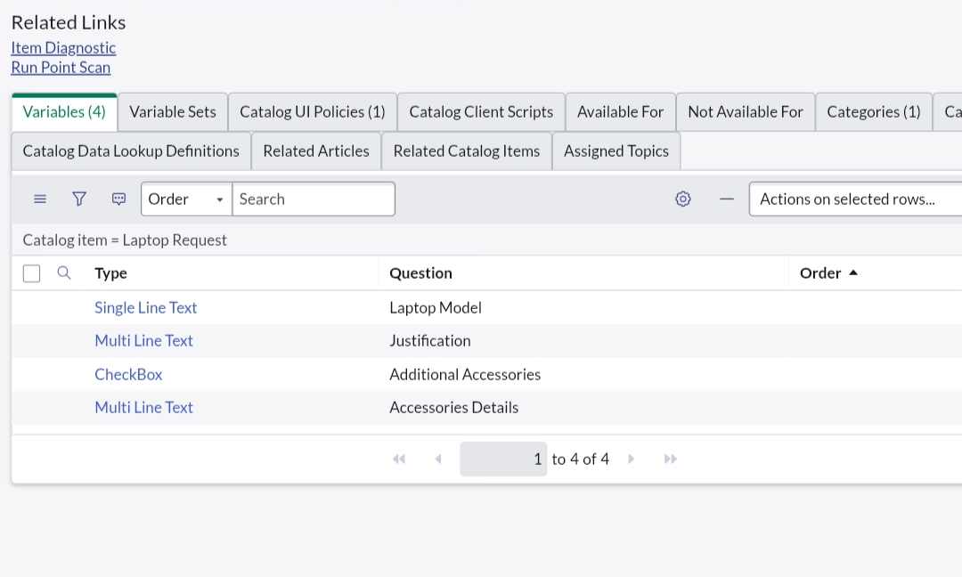

**Milestone 3**: UI Policy and UI Action Configuration



* UI Policies were created to manage dynamic behavior of the form. For example:
* Making justification a mandatory field.
* Displaying accessories details field only when the “Additional Accessories” option was selected.

Create Catalog Ui policies

* Click on all>> search for service catalog
* Select maintain item under catalog definition
* Search for ‘laptop request’ which is created before
* Select ‘laptop request’ and scroll down click on “Catalog Ui policies”
* In the catalog ui policies related list tab click on new
* Give short description as: show accessories details
* Set the Catalog Condition in the related list tab ‘when to apply’

[field: additional_ accessories, operator: is, value: true]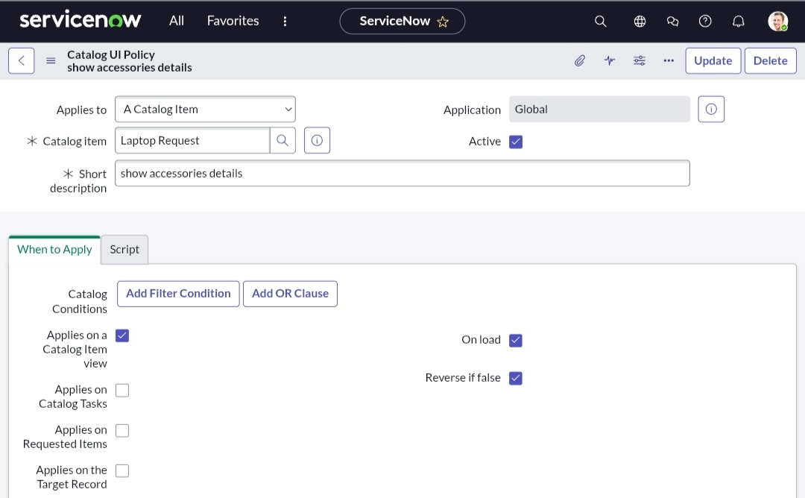



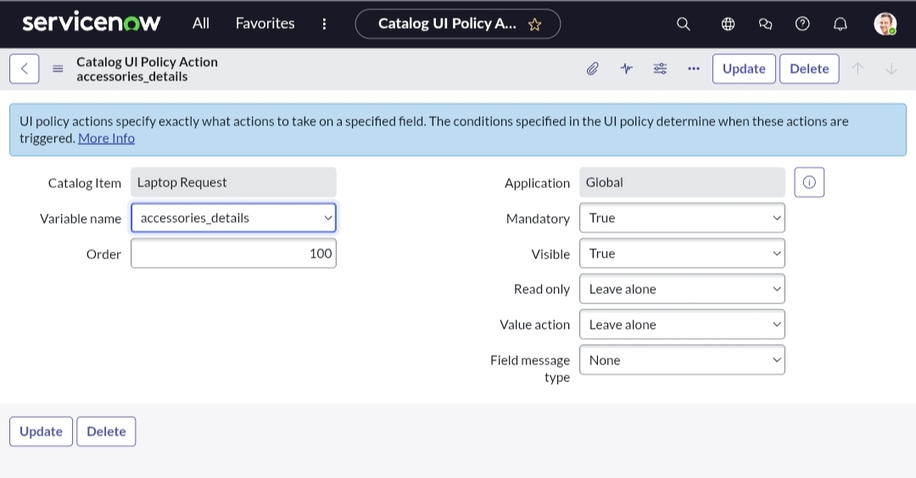

* UI Actions were created to add extra functionality, such as customizing the Order Now button and improving the request submission process

Create ui action

* Open service now.
* Click on All >> search for ui action
* Select ui actions under system definition
* Click on new
* Fill the following details to create ui action
* Table: shopping cart(sc_cart)
* Order:100
* Action name: Reset form
* Client : checked



Script:

function resetForm() {

g_form.clearForm(); // Clears all fields in the form

alert("The form has been reset.");

}

* Click on save

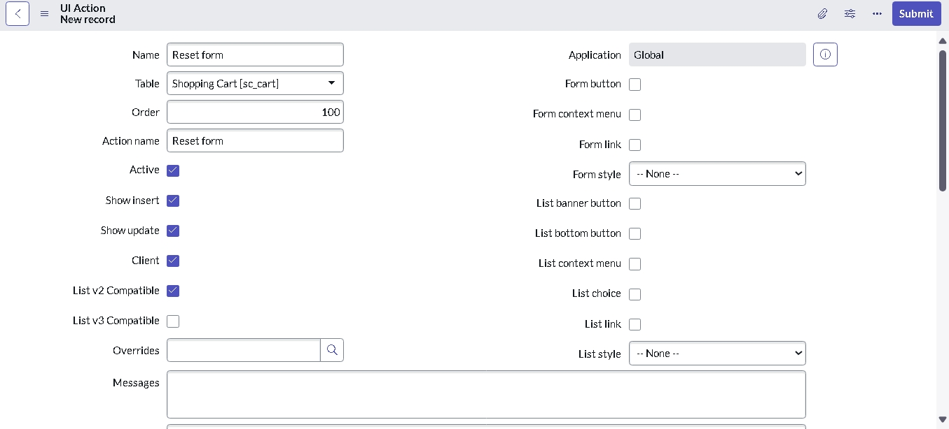

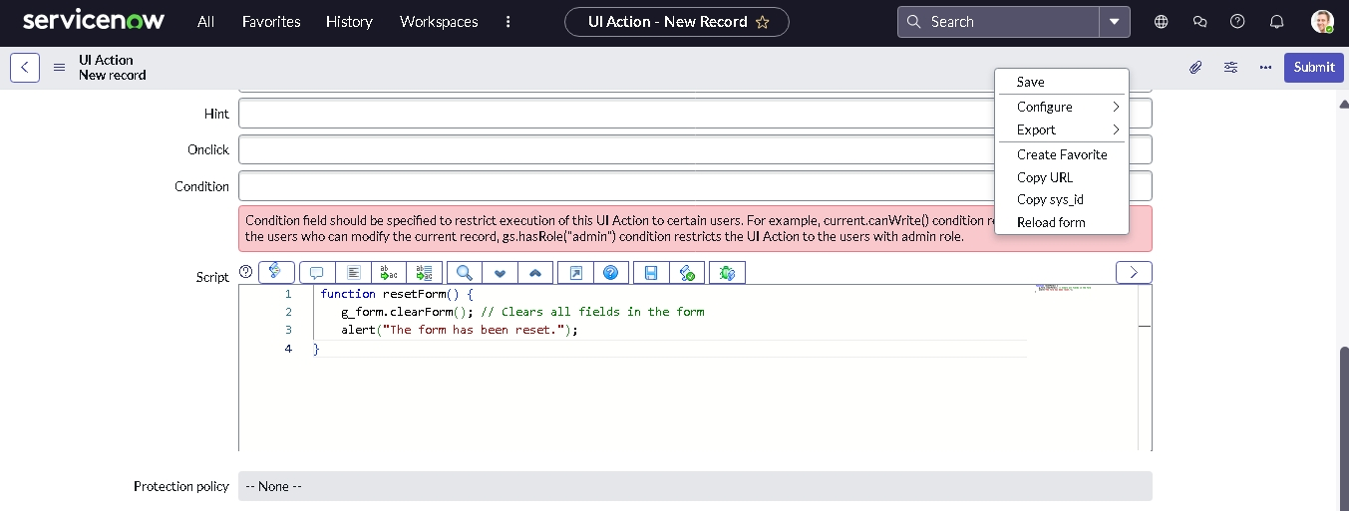



**Milestone 4**: Update Set Migration

The migration of the Laptop Request Catalog Item was carried out using the Update Set feature in ServiceNow. The steps included:

1. **Export Update Set to XML**

* After completing development, the Update Set was marked as Complete.
* From the Related Links section, the update set was exported as an XML file.

Exporting changes to another instances

* Click on All >> search for update sets
* Select local update set
* Select created update set i.e. ‘Laptop Request Project’
* Set the state to ‘Complete’
* In the related list Update tab, updates are visible which we perform under this update set.
* Click on export to XML ,it download one file

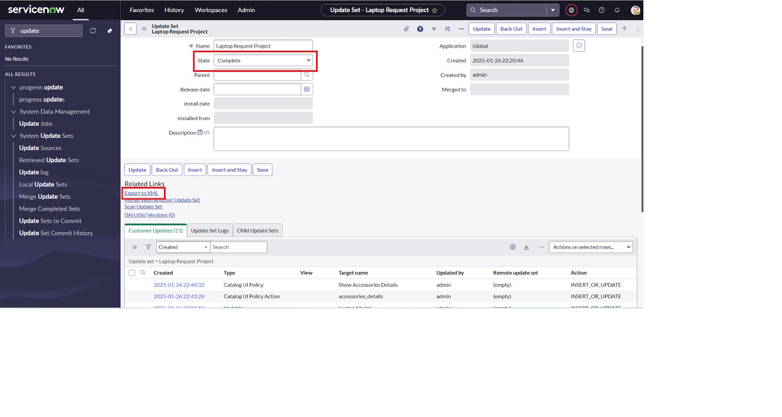



**2. Retrieved Update Set**

* In the target ServiceNow instance, navigation was done to Retrieved Update Sets.
* Here, the option Import Update Set from XML was selected.

Retrieving the update set

* Open another instance in incognito window
* Login with credentials
* Click on all>> search for update sets
* Select “Retrieved update set” under system update set
* It open retrieved update set list and scroll down
* Click on Import update set from XML

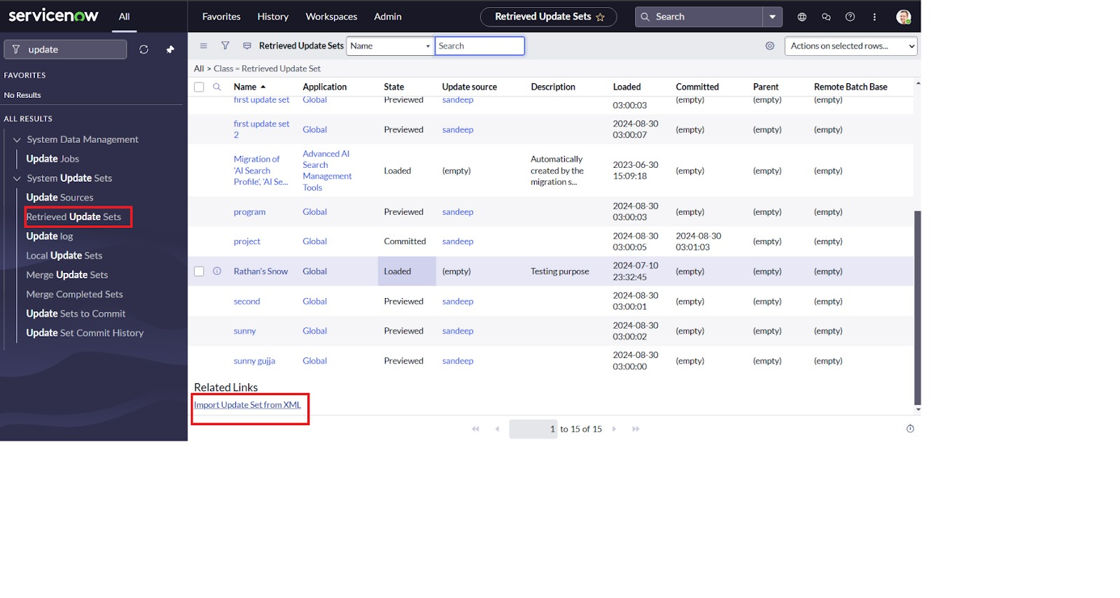



**3. Upload XML File**

* The exported XML file was chosen and uploaded into the new instance.
* Once uploaded, the update set appeared in the list of retrieved update sets.

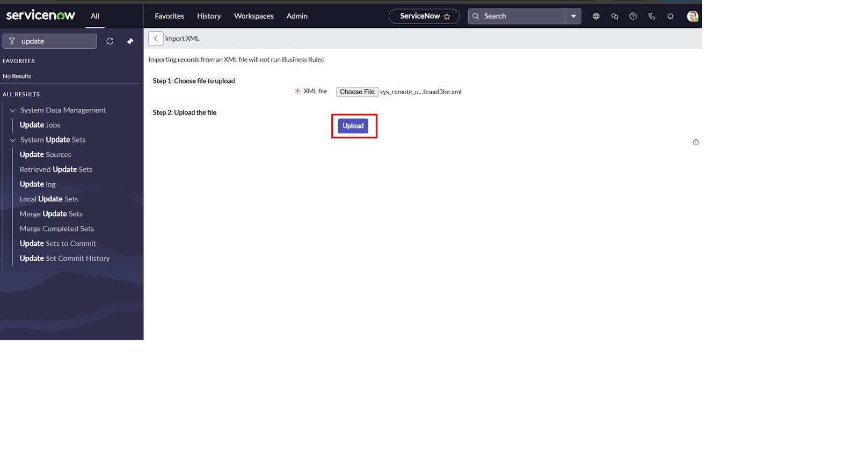

**4. Preview Update Set**

* The retrieved update set was previewed to check for errors, conflicts, or missing dependencies.

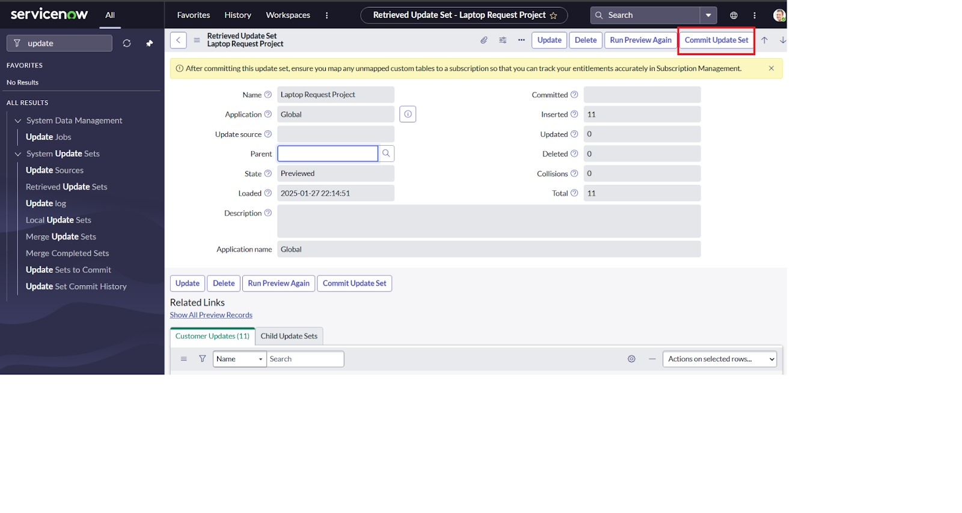



**5. Commit Update Set**

* After successful validation, the update set was committed.
* This applied all the changes (Catalog Item, Variables, UI Policies, and UI Actions) into the target instance.

**Milestone 5**: Testing and Validation

The final stage involved testing the Laptop Request Catalog Item from the Service Portal.

* The form was opened, and test data was entered (Laptop Model = Dell, Justification = “Need for project work”, Accessories = Keyboard).
* The request was submitted successfully, generating a unique Request Number (REQ).
* The request followed the designed workflow and moved through approval and fulfillment stages.
* This validated that the catalog item, variables, UI policies, UI actions, and workflow were working as intended

Test Catalog Item

* Search for service catalog in application navigator in target instance
* Select catalog under service catalog
* Select hardware category and search for ‘laptop request’ item
* Select laptop request item and open it
* It shows three variables only
* As per our scenario, when we click on additional accessories checkbox then accessories details fields is visible and that should be mandatory
* Now see the results,it fulfills our requirements

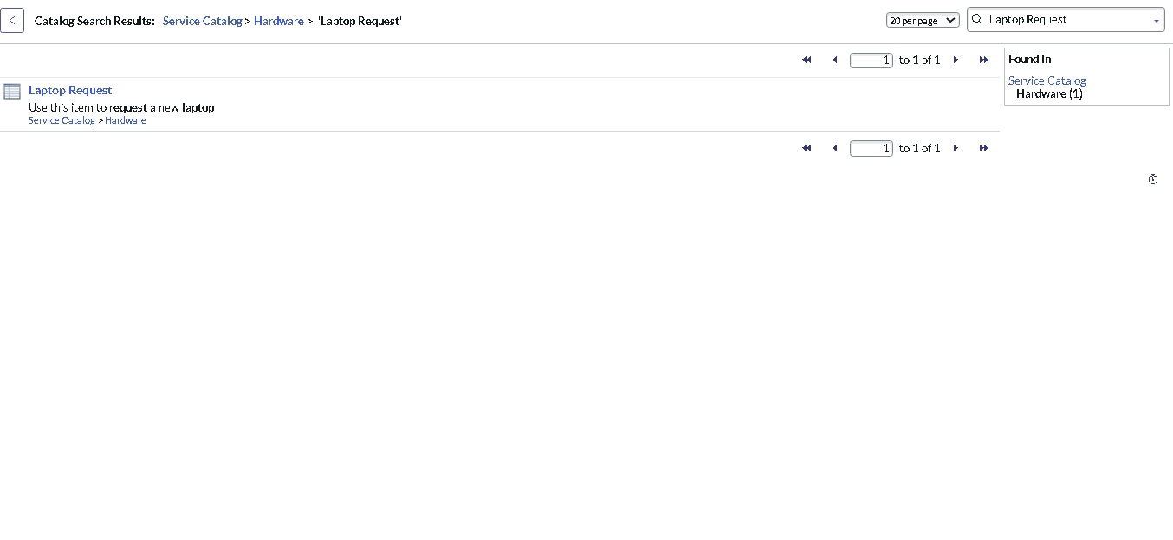

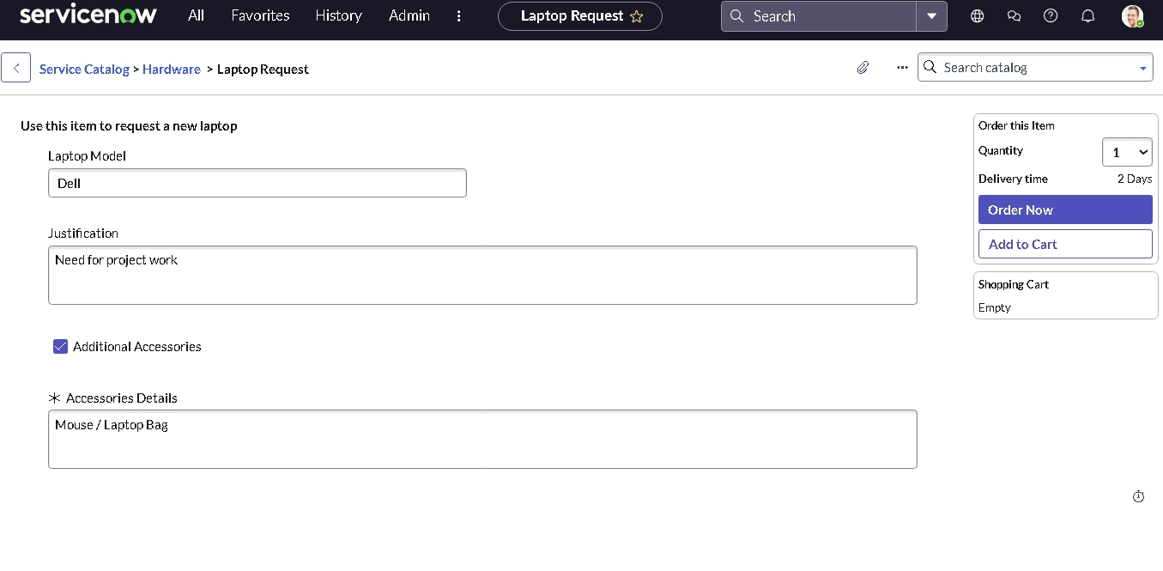



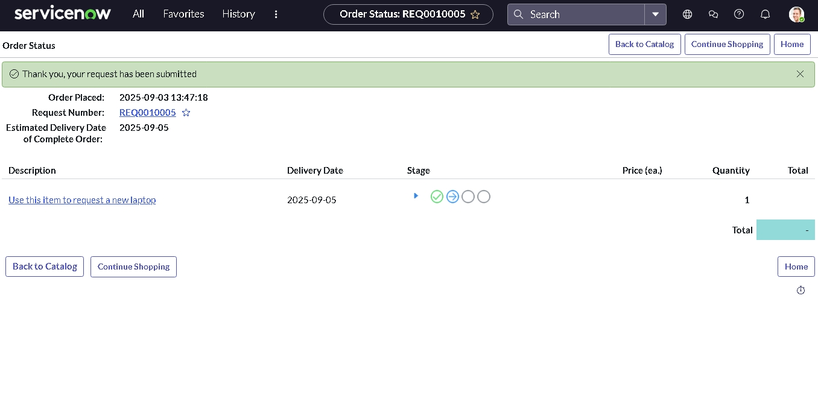

**Conclusion**

Through this project, I successfully created and tested a Laptop Request Service Catalog Item in ServiceNow. The implementation helped automate the manual laptop request process, making it faster and more efficient. By adding variables, UI policies, and UI actions, I ensured the form was user-friendly and dynamic. The use of update sets allowed me to capture, export, and migrate changes between instances effectively. Finally, testing in the Service Portal confirmed that the catalog item was working as expected. Overall, this project gave me a practical understanding of ServiceNow customization, request automation, and IT service management best practices.

**Project demo link:**

<https://drive.google.com/file/d/1-f49JQzY8VcL715broVWM800dBThiqBJ/view?usp=drivesdk>

GitHub Link :

<https://github.com/abdulbasith-123/Laptop-request-service-catalog-Item-.git>

Project File : <https://drive.google.com/file/d/1275FlPO9bWMlhKTWDkfGhfHENVbKSkFy/view?usp=drivesdk>